**Exercise no:**4

**Register no:** 1518102710

**Date:**17.10.2020

**Aim:**

To print a single string from two set of strings received from user and swap the first two characters of each string.

**Program:**

def swap(s):

new=""

for x in s:

new+=x

return new

char1=input()

char2=input()

a=char1.strip()

b=char2.strip()

if(len(a)>=2 and len(b)>=2):

t1=list(a)

t2=list(b)

c1=t1[0]

c2=t1[1]

t1[0]=t2[0]

t1[1]=t2[1]

t2[0]=c1

t2[1]=c2

a=swap(t1)

b=swap(t2)

print(a,"",b)

else:

print("invalid")

**Output:**

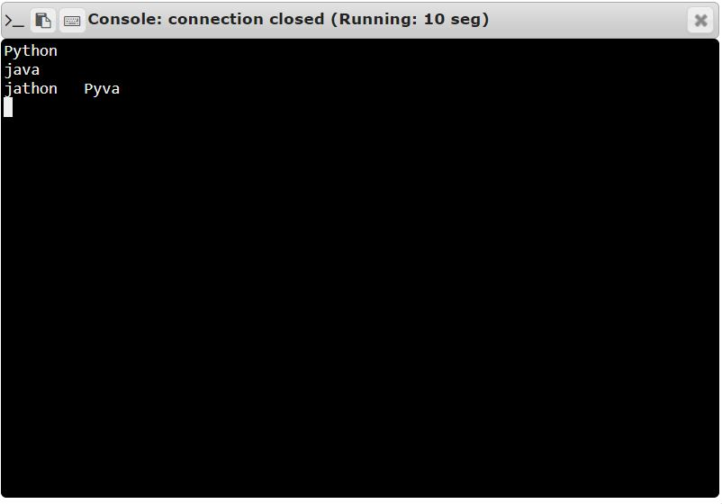

**Result:**

Thus the code has been successfully executed and output is verified.